GitHub Repository Review
Repository: DFE-Digital/sap-sector

Schools Profiles

Sector Facing

(Draft for SME Validation)

Service: Schools Profiles – Sector Facing

Author: Neil Roberts

Document Control
Version | Date | Description | Author
0.1 | Apr 2026 | Initial Draft to complete for peer review | Neil Roberts

Contents
Executive Summary 3
1. Purpose and Scope 3
Observations 4
1. High-level observations (important context) 4
2. Contents review (what is present vs missing) group by generic areas 4
What’s good 5
Concerns / risks 5
What was expected based on DfE norms 6
Recommendations 6

Executive Summary
The GitHub repository contains initial documentation, but shows minimal activity and lacks basic signals of currency, ownership, and versioning. It doesn’t look used. For a Schools Profiles Sector-facing resource, this introduces a risk that content may be outdated or misused without clear assurance

Purpose and Scope
Purpose
The purpose of this exercise is to discover what is in the repo and compare that with what we believe should be present and create a list of any gaps to fill and any required actions.
Scope
This is for Schools Profiles – Sector Facing
Out of scope
- Schools Profiles – Public Facing

Observations

1. High-level observations (important context)
- The repository is public but extremely lightweight
- It shows only 1 commit and no releases, which strongly suggests:
  - Either it is very recently been set up or
  - It has not been actively developed or maintained
- There is no visible evidence of recent activity
- The repo is labelled as “sector facing output”, which implies:
  - Non-technical audience
  - For this reason, documentation quality and clarity are especially important

2. Contents review (what is present vs missing) group by generic areas
Summary table
Area | Item | Present | Last updated | Comment | Gap or Risk
Purpose | README | Yes | Not clearly visible | States repo is “Sector facing output of the SAP project” | Lacks scope, audience, and should really define what “sector” means
Documentation | /docs folder | Yes | Not clearly visible | Indicates intention to document outputs | Content appears minimal / hard to assess freshness
Governance | Code of Conduct | Yes | Not recent | Standard org-level file | No repo-specific governance
Security | Security policy | Yes | Not recent | Standard GitHub/DfE security | No data classification or handling notes
Versioning | Releases | No | N/A | No versioned outputs | Sector users can’t tell what’s current
Change history | Changelog | No | N/A | No visibility of evolution | Risk of outdated guidance being reused
Ownership | Maintainer / owner info | No | N/A | No accountable owner named | How do users know who to contact
Currency | Update cadence evidence | Weak | Single commit | Suggests repo may be static | High risk that the content is stale
Usability | How to use outputs | No | N/A | No “how to use / consume this” | Limits value I think
Assurance | Document status (draft/final) | No | N/A | No confidence signal | Real risk of misuse or misinterpretation

Example:
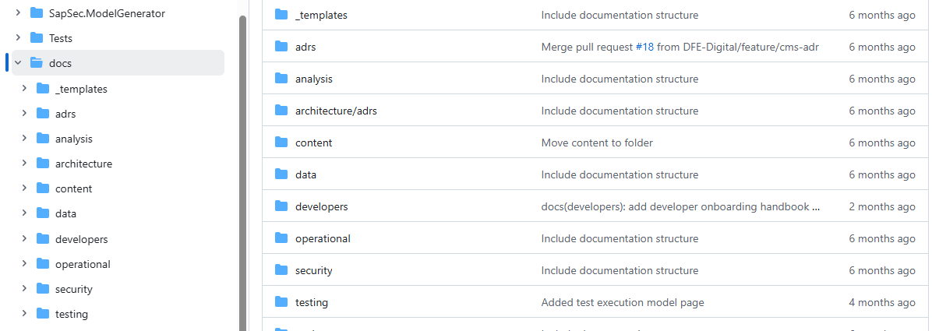

What’s good
- The Repo supports “coding/documenting in the open”
- It’s clearly in alignment to the programme (SAP) and it
- Contains basic organisational files (Code of Conduct, Security)

Concerns / risks
- Only one commit strongly implies:
  - Little iteration, just uploaded and left
  - No ongoing maintenance. Should be a review cycle for the artefacts.
  - The folders haven’t been updated in 2, 4 and often 6 months, so even the good content will be overdue for review to see if it is still relevant
- No release tags or versions
  - Isn’t Sector-facing material normally versioned?
- No freshness signals
  - As a reader it’s not possible to tell if content is current, withdrawn, or superseded
- Audience not defined
  - “Sector” is ambiguous (schools? suppliers? local authorities?) does it need to be more specific, or is this description enough internally?

What was expected based on DfE norms
Based on comparable DfE Digital repositories and sector-facing guidance (and I realise that I am only aware of some of them) the following could be commonly expected but are absent:
- A clear overview:
  - What SAP is
  - What outputs are included
  - What is not included
- A “Who this is for” section
- A last reviewed / last updated date
- Named product owner or team
- A change log or version history
- Status labels:
  - Draft / Live / Deprecated
This section is just highlighting documentation governance gaps here, not technical ones.

Recommendations
It really depends on what was expected to be in the repo but the recommendation is to:
- Update README
  - Define audience, scope, status, owner
- Add content status markers
  - e.g. “Last reviewed: June 2024”
- Introduce basic versioning
  - Even lightweight release notes
- Name an accountable owner
  - The Team or central Mailbox should be enough
- Confirm intent
  - Is this repo meant to grow, or is it archival, I can’t see what was intended?

End of Draft Document

